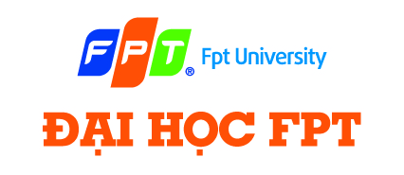

|  |
| --- |
| **FPT UNIVERSITY** |
| Capstone Project Document |

**SMART MEDICINE DICTIONARY**

Report #1 - Introduction

|  |
| --- |
|  |
| |  |  | | --- | --- | | **Smart Medicine Dictionary** | | | **Group Members** | |  |  | | --- | --- | | Lê Thị Xuân | 01913 | | Phạm Huy Khôi | 01888 | | Phạm Minh Tú | 01770 | | Phạm Hà Hải | 01727 | | Ngô Hà Thu | 01522 | |  |  | | | **Supervisor** | Mr. Nguyễn Văn Sang | | **Project code** | SMD |   - Hanoi, 8/2013- |

**Table of Contents**

1 PROJECT INTRODUCTION 4

1.1 Purposes 4

1.2 Acronym and Definition 4

1.3 Background 4

1.4 Literature review 5

1.5 Proposal 9

1.5.1 The Idea 9

1.5.2 Brief description about system 9

1.5.3 System features 10

1.6 Objectives 11

1.7 Potential risk and limitation 11

1.8 Benefit from project 12

1.8.1 For Pharmacy 12

1.8.2 For our Group 12

1.8.3 For Community 12

1.9 References 12

# PROJECT INTRODUCTION

## Purposes

This document is prepared as the introduction for project Smart Medicine Dictionary, in scope of Capstone Project at FPT University. It does not only explain the basic concept and idea for our project but also discuss what project’s benefits and threats are, what opportunities it offers and what existing medical problem it solves.

## Acronym and Definition

|  |  |
| --- | --- |
| **Acronym** | **Definition** |
| SMD | Smart Medicine Dictionary |
| GPS | Global Positioning System |
| SQL | Structured Query Language |

**Table 1-1:** Acronym and definition

## Background

Medicine is the applied science or practice of the diagnosis, treatment, and prevention of disease. It encompasses a variety of health care practices evolved to maintain and restore health by the prevention and treatment of illness in human beings. Nowadays, it is an important part of our life and get a lot of concern from society.

When you get a prescription medicine from a doctor, you likely know what the medicine is for, but do you know how it is going to work? Learn about common prescription medicines, how they work, and foods, medicines or activities you should avoid while taking them. The more you know about your prescription medicine, the better it will work.

Not only prescription medicines but also over-the-counter medicines can interact with each other or with prescription drugs and cause problems. Supplements, herbal products in teas or tablets, or vitamins may also cause adverse reactions when taken with certain drugs. User should know about the reactions of each medicine they take.

There are some kind of work such as pharmacist, medical students… need to look for more information of medicine, herbal… They have to look up from medical dictionary books, which is so thick, heavy and take a lot of time to find exact medicine. Specially, books cannot automatically be updated so they also have to spend much money to buy a new one.

It might be hard to find out the correctly information about the medicine through the internet. Therefore, with that software, we hope user can surf information of which medicine they interest whenever and wherever through their mobile devices

In the busy life, sometime, we may not remember our medicine taking schedule, doses or prescription. That make it hard to maintain the treatment process

Nowadays, it is time of technology, thus, a lot of pharmacies have demand for public their information in the internet for widely promotion but there is not much software for pharmacy to interact with each other and user. Therefore, looking for a local pharmacy or the way to get there is also a problem. Specially, in case that we get hurt and need medicine or first aid equipment immediately.

The SMD project aims to build a system for medical services that improve and enhance the current state, overcome these weaknesses. In another hand, system displays totally in Vietnamese, therefore, it can easily be used by doctors, pharmacist, medical users… who is Vietnamese people and does not understand English

## Literature review

Currently, there are so many website and android software about medical that help users looking for medicine information, find out pharmacy address such as: Medscape.com, Medical handbook, Thuoc.net…

* **Medical Handbook:**

In overview, that software has only search function with 3 options: search for drug, disease or medical plant. Therefore, it is easy to use. Users can easily learn about the symptoms and various treatments and make decision when choosing a medicine.

* **Advantages:**
* Easy to use
* Have plenty of options to search
* **Disadvantages:**
* Display only in English, not be appropriate with Vietnamese
* Just have search feature

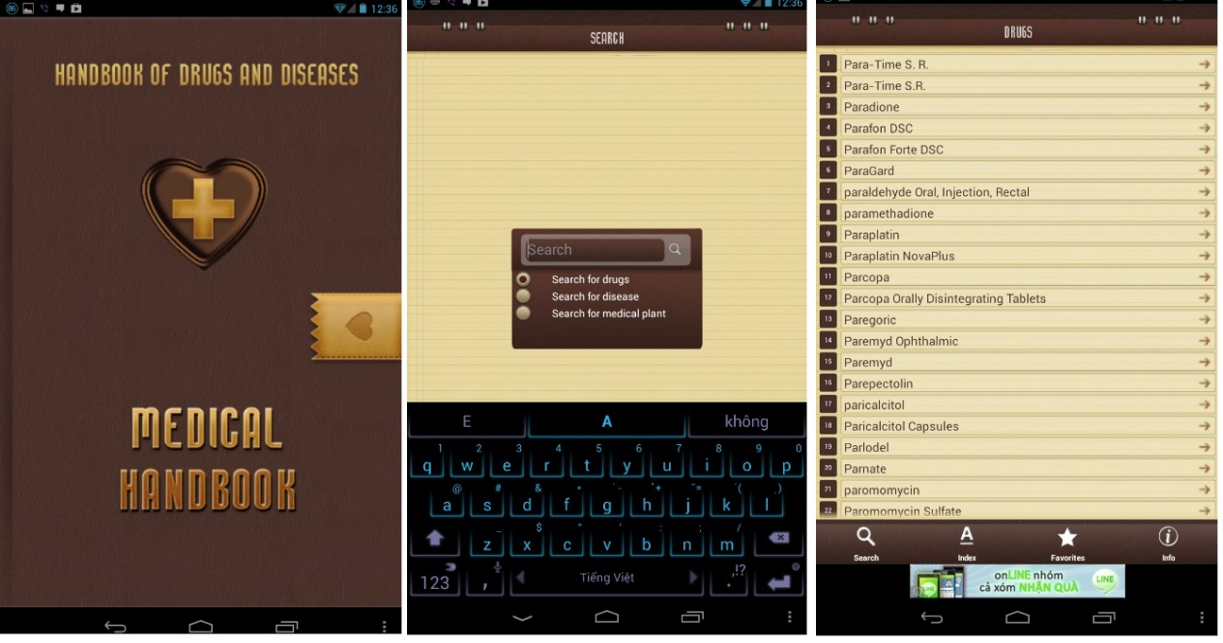

F**igure 1-1:** Medical Handbook interface

* **Medscape.com:**

That software has a very strong and professional tool with two versions: for mobile and for web with multi-function.

* **Advantages:**
* With “Drug” option, user can directly search for drug information by its name. If they have no idea about which medicine they should use, they can look it up by disease. That program default group the medicines by disease
* User can learn about one disease by “Condition” option
* User can also learn about popular procedures
* Another useful function is “interaction”. User can insert the medicine list that they take to see if they conflict each other
* “Direction” list address and contact of the hospital, pharmacy
* In addition, that program also update medical news daily.
* **Disadvantages:**
* Display only in English
* Can only be used after register

However, user can only use these function after they have register an account. Beside it, because of too much function, users might find difficult at first time using it.

* **On Mobile:**

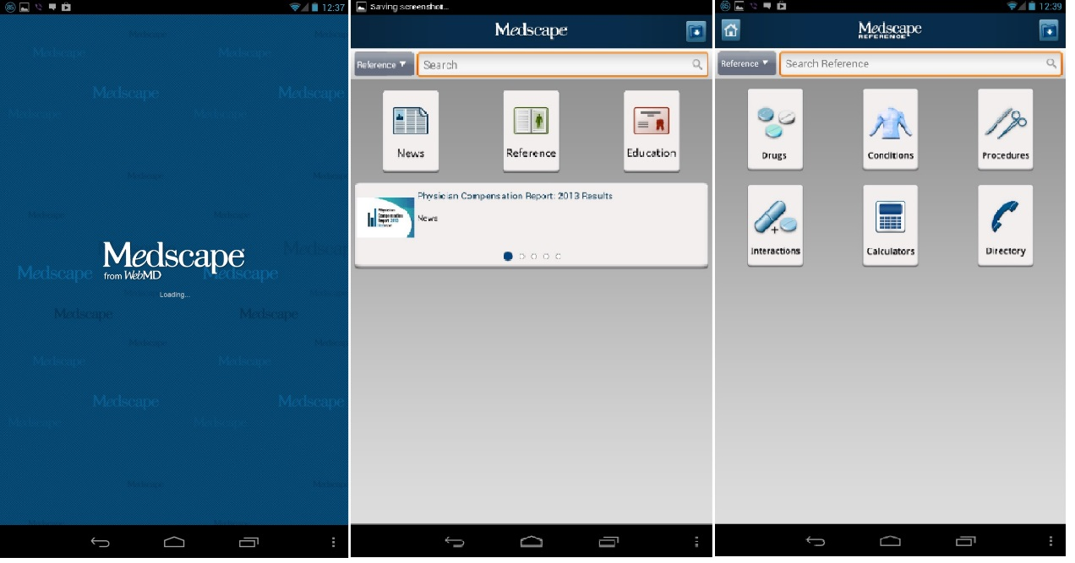

**Figure** **1-2**: Medscape mobile interface

* **On web:**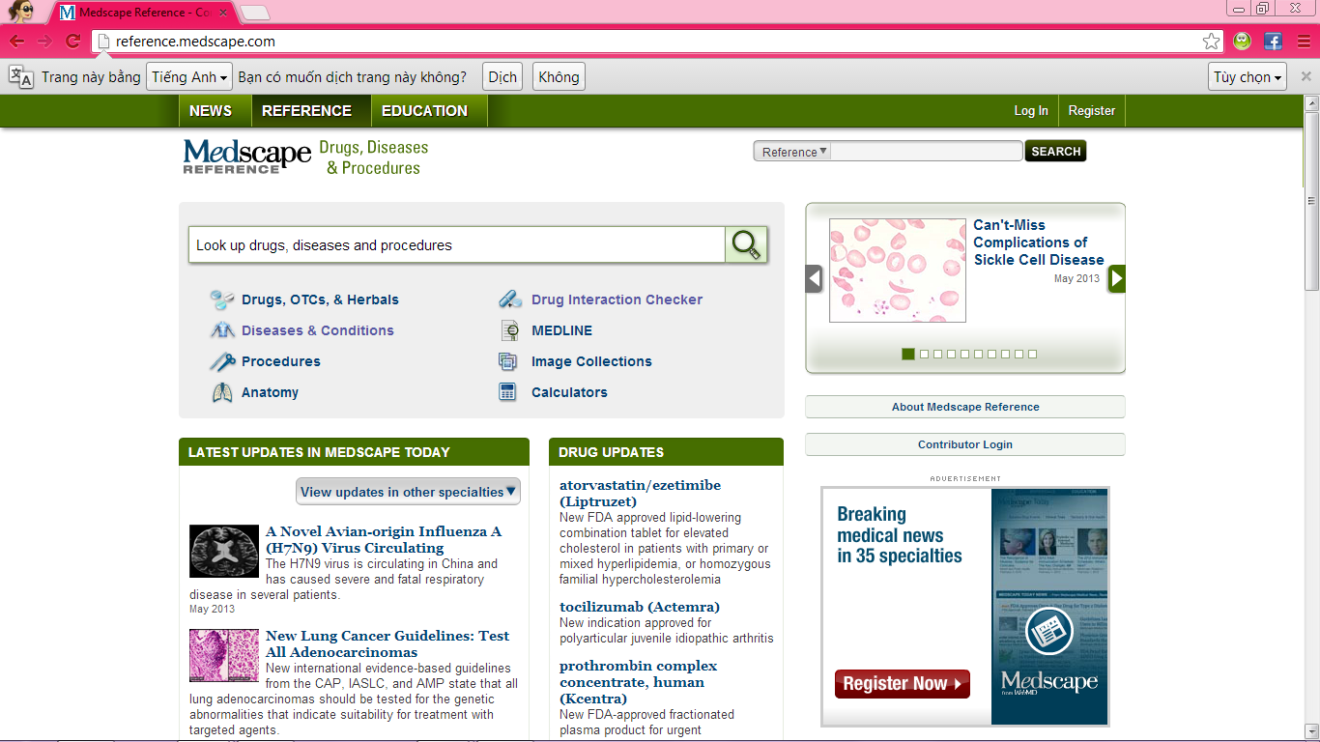

**Figure 1-3:** Medscape web interface

* **Thuoc.net**

In overview, that website have supported user quite well with many general feature of a standard medical website:

* **Advantages:**
* User can search medicine by name, number, ingredient, interaction. Beside it, they can also look up for articles, video, images, services of each diseases
* It also contain medical news, services, advisory, market, …
* With advisory function, user will post their question, then the doctor of ThuocNet will answer it
* **Disadvantages:**
* Filter feature works not good, it will search all data by full text search technique. Therefore, it can show so much results. User may find it 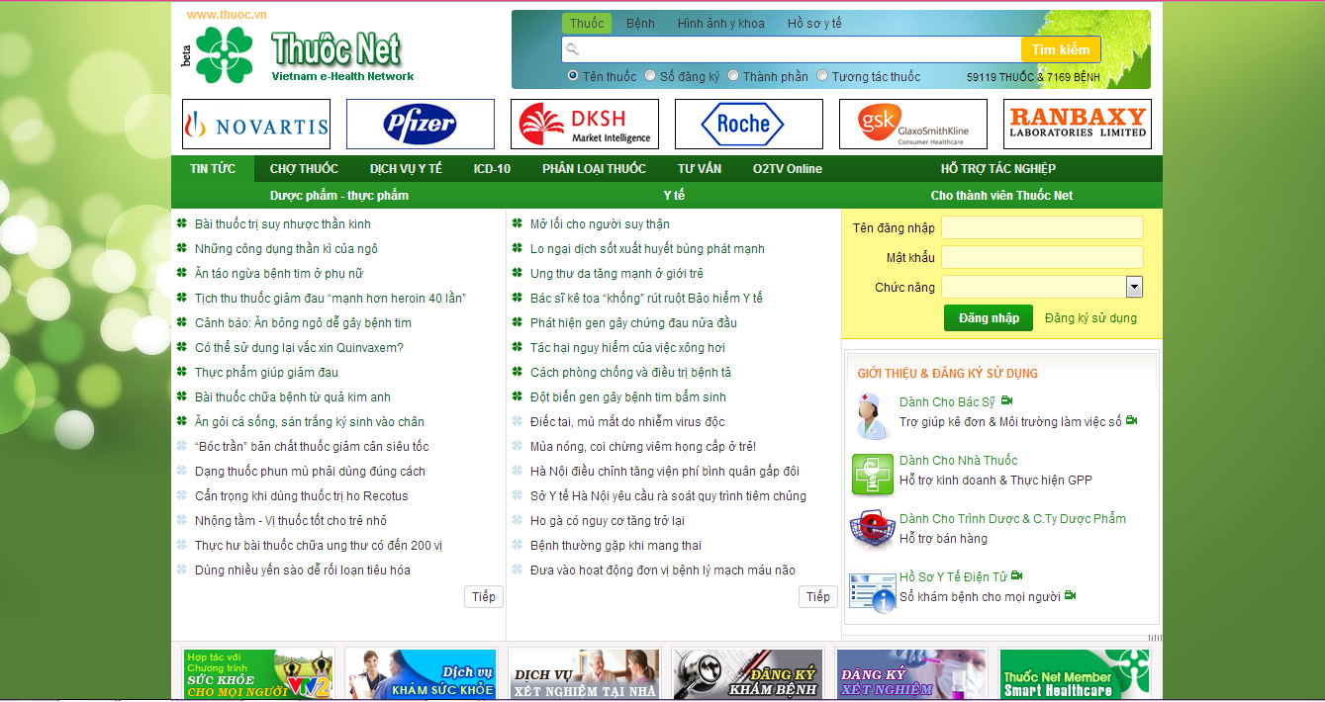is hard to choose the right one.

**Figure 1-4:** Thuoc.net web interface

* **iThuoc:** This software has only search function that is similar to Medical Handbook
* **Advantages**:
* Easily to use
* Can be used without connecting to the internet
* **Disadvantages:** Too simple, with this software, user can only search 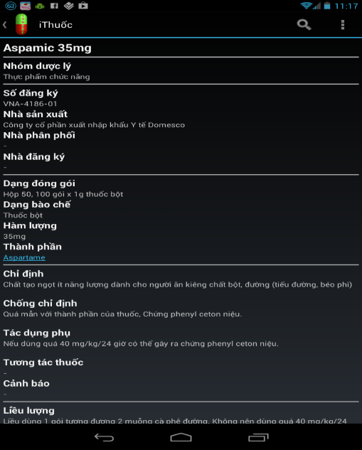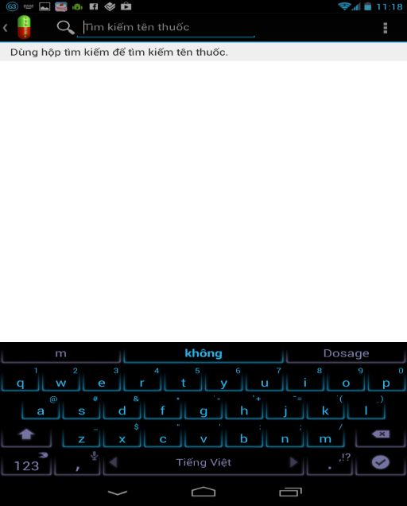medicine by name

**Figure 1-5:** iThuoc mobile interface

In overview, existing systems have supported users well with multi functions. However, they display fully in English. With some Vietnamese applications and websites, their function is too simple but sometime, user might find it hard to use.

## Proposal

### The Idea

The idea of creating SMD software about medical is not new. However, the intended developing SMD will includes almost all fulfill functions of software used English as the main language. Therefore, the project group aims at bringing a better, faster and easier software which displays totally in Vietnamese that is easier for Vietnamese people.

### Brief description about system

That software has two versions for web and for mobile. With friendly interface, user can easily find out what they want without registration. Moreover, user can know more about the interaction between two kinds of medicine. It also displays the appropriate medicine that have similar uses with searched medicine. Therefore, user can reference to make the best choice for themselves. In addition, with pharmacy management function, our software can bring the best trustful pharmacy to users. It is also useful when users are staying at strange location and need to find out the rout to the nearest pharmacy.

Mobile send input to or retrieve information from through Webservice, Webservice implementation function and send return output to mobile

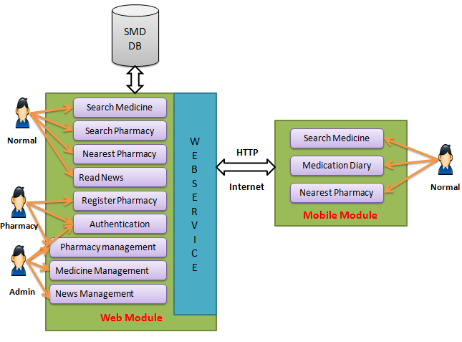

**Figure 1-6:** Global picture

SMD system uses familiar technologies as: JavaScript, Strut 2, Spring 3, Hibernate 3, Android (mobile)… It is support operating systems such as windows and current browsers as Firefox 20, Chrome 25 or above.

### System features

* **General feature** (run on both mobile and web module)**:**
* Search medicine by name (auto complete)
* Find pharmacy location on map
* Show the route to the nearest pharmacy
* **Mobile application feature:**
* User can **find the nearest pharmacy** by typing their location or that software will access to their location **through the GPS** satellite. Then it will display the route with the instruction to help user easily reach to that pharmacy
* With **Medical Diary** function, user can save their medicine taking schedule, dosage or set alarm to remind them to take medicine in time.
* **Web application feature:**
* User can do advanced search for medicine with many options such as: medicine name, manufacture, indication, contraindication, ingredient, packaging or where that medicine is sold.
* Advanced search pharmacy
* The register form for pharmacy displays only on web version. It is easy to fill with general information, they can subscribe their location in the map or upload their picture, stock data to help user know more about them.
* Registered pharmacy will be provided an account that has role to edit, update or add new their database.
* Provide management feature for administrator to:
* Medicine management: search, add new, edit, delete, restore medicine
* Pharmacy management: accept or reject pharmacy registration, delete pharmacy information
* News control: Add, edit, delete news
* Provide news about medical and health

In near future, we might add another helpful function for user, that is diagnose the diseases online

## Objectives

This project is registered and implemented as the capstone project for the team members. The first purpose is to fulfill the requirements from FPT University studying program. Our project uses some new technology that we have not studied at the University such as: develop for Android OS, test on simulator, code in strut, spring… technique. And it is also a chance for us to work as a real project team which is nearly to the environment that we will work after graduated. We have to learn how to control our time, our source code, hold a meeting, connect and communicate to other team members. Therefore, after get through that project, we can not only practice what we have studied but also have learned many new things to be ready to our future work

The second purpose is to create a complete product to support pharmacy and people who concern with medical problem. It might not have fulfill function as foreign system but it can response the basic demand like search medicine information, find nearest pharmacy… Specially, that software displays completely in Vietnamese, so that even user does not know English, they can easily use it

## Potential risk and limitation

After studying about this project, we find out some problem that we may be encountered:

* We do not have much experience in exchange information, managing and controlling work so we might be missed the deadline or out of scope
* We have not much knowledge in the framework and technique of both mobile and web (Such as: Strut, Spring, Hibernate… technique). Therefore, we have to study all of these things from the beginning. This work takes a lot of times. The project team may face with the difficult technical problems that may requires long time to resolve so that causes the project be delayed.
* We find it is hard in collecting data and studying the business about medical. If we misunderstand something, we might develop the system in the wrong way
* About testing in device, it also an economic obstacle (because no member in our team have an android device, we need to buy a new one to support testing process)
* Location access through GPS satellite in mobile is depended so much on the infrastructure of the network providers. It takes a lot of time of mobile developer to code and test “Find nearest pharmacy” by GPS function
* In addition, we also have difficulty in using some tools such as Microsoft Project, Eclipse, My SQL, Source code managing… Therefore, our work management may be not good.

Sometime, because of careless, team members can lose data, source code… before uploading to server

## Benefit from project

After implementing this project not only pharmacy have benefit in promotion, develop group and community also have many benefits

### For Pharmacy

Pharmacy uses SMD will save cost to advertise but still gain the effective. With technology power, many people can know about them and easily find way to get there through the direction on map

### For our Group

After developing and implementing that project we will:

* Understand new technology like Android, Eclipse Indigo, Strut, Spring, Hibernate, My SQL, Source code managing…
* Have the opportunity to experience and improve working in group skill
* Know how to manage project, limit risk, control working time more effective
* Know more about the business of pharmacy and have more knowledge in medical

### For Community

Just need to have a device that connect to the internet, user can:

* Search for more information about medicine that they take or concern
* Easily find out the nearest pharmacy and the shortest way to get there
* Have guarantee for trustful pharmacy
* Save their medicine taking schedule, dosage or set alarm to remind them to take medicine in time with their android devices
* Find out which pharmacy sells the rarely kind of pharmacy that they need
* Be up to date with medical news

## References

**[1] Medical Handbook** (Mobile version only): <https://play.google.com/store/apps/details?id=com.itsoftgroup.medicine&feature=search_result>

**[2] Medscape**:

* Website: <http://www.medscape.com/>
* Mobile: <https://play.google.com/store/apps/details?id=com.medscape.android&feature=search_result#?t=W251bGwsMSwxLDEsImNvbS5tZWRzY2FwZS5hbmRyb2lkIl0.>

**[3] iThuoc:** (mobile version only)

<https://play.google.com/store/apps/details?id=com.vm.ithuoc.free&feature=search_result#?t=W251bGwsMSwxLDEsImNvbS52bS5pdGh1b2MuZnJlZSJd>

**[4] Thuoc.net:** <http://www.thuoc.net.vn/>